- DES (13)

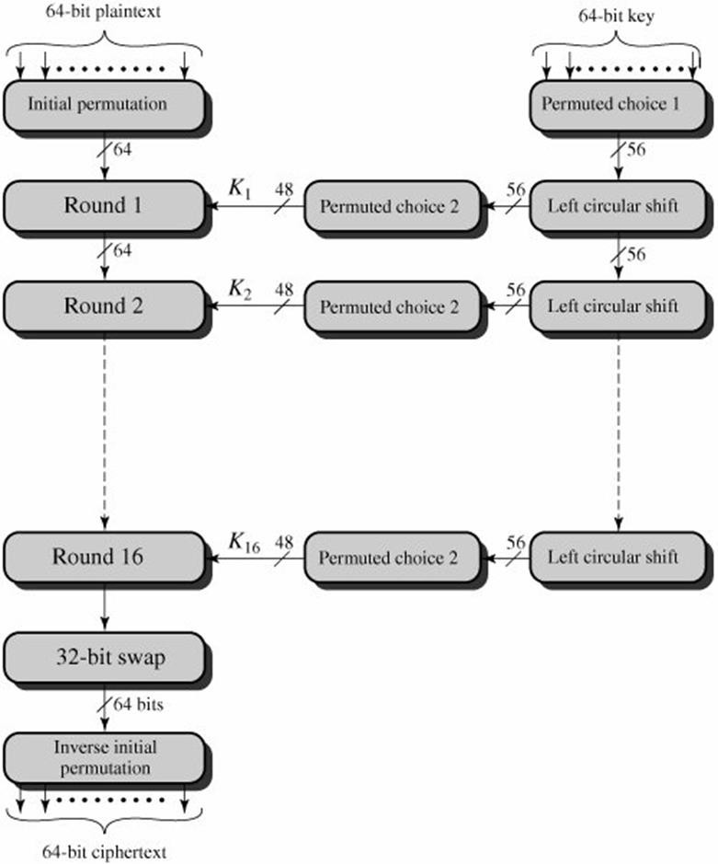
- The DES Algorithm is a block cipher.

- It uses symmetric keys to convert 64-bit plaintext blocks into 48-bit ciphertext blocks.

- The DES Algorithm was developed by the IBM team in the 1970s.

- The DES encryption algorithm uses symmetric keys, which means that the same key is used for encrypting and decrypting the data.

DES Algorithm Steps

Let us take a look at the steps involved in the DES algorithm:

- The initial permutation (IP) function receives the 64-bit plaintext block.
- The IP is performed on plaintext.
- The IP then makes two halves of the block that has been permutated. The two halves are known as left plan text (LPT) and right text (RPT).
- All LPTs and RPTs are encrypted 16 times.
- The LPT and RPT are joined, and then the final permutation (FP) is performed on this block.
- The 64-bit ciphertext is now ready.

Single Round DES Algorithm
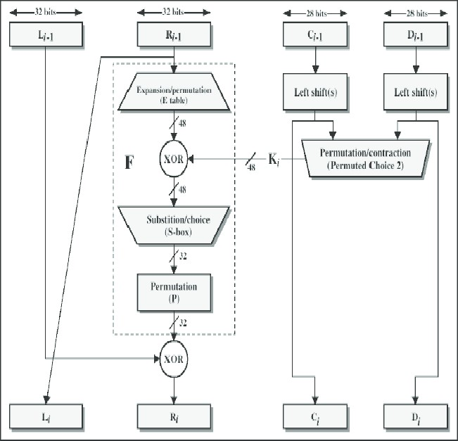

The left and right halves of each 64 bit intermediate value are treated as separated 32- bit quantities labeled L (left) and R (Right). The overall processing at each iteration is given by following steps, which form one round in an S-P network.

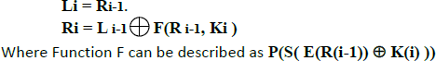

The left hand output of an iteration (Li) is equal to the right hand input to that iteration Ri-1. The right hand output Ri is exclusive OR of Li-1 and a complex function F of Ri-1 and Ki. The fucntion F can be depicted by the following figure. S1, S2 S8 represent
the ”S-boxes” , which maps each combination of 48 input bits into a particular 32 bit pattern. Each S-Boxes accepts 6 bits as input and produces 4 bits as output. Example: Input 011001, the row is 01 (row 1) and the column is 1100 (column 12). The value in row 1, column 12 is 9, so the output is 1001.

S-Boxes

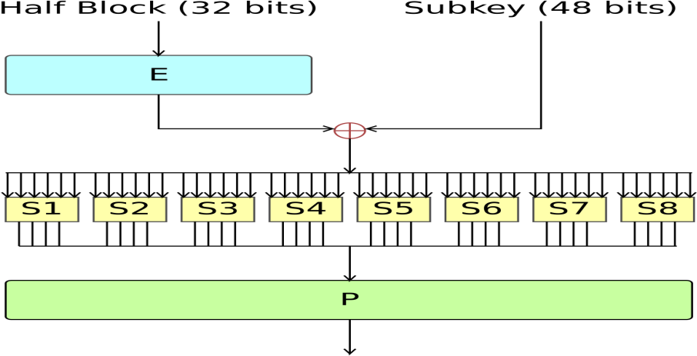
- uses two 32-bit L & R halves
- as for any Feistel cipher can describe as: Li = Ri–1 Ri = Li–1 xor F(Ri–1 , Ki )
- takes 32-bit R half and 48-bit subkey and:

  - Expands R to 48-bits using Expansion Permutation E

  - Adds to subkey – passes through 8 S-boxes to get 32-bit result

  - Finally permutes this using 32-bit Permutation Function P

DES Decryption
Decryption uses the same algorithm as encryption, except that the application of the subkeys is reversed.
- Strength of DES (8)

- Key Size

  - 56-bit keys have 256 = 7.2 x 1016 values
  - Brute force search looks hard
  - Still must be able to recognize plaintext
  - Now considering alternatives to DES

Timing Attacks
- attacks actual implementation of cipher
- use knowledge of consequences of implementation to derive knowledge of some/all subkey bits
- specifically use fact that calculations can take varying times depending on the value of the inputs to it

Analytic Attacks
  - These utilise some deep structure of the cipher
    - By gathering information about encryptions
    - can eventually recover some/all of the sub-key bits
    - if necessary then exhaustively search for the rest
  - Generally these are statistical attacks
  - Include
    - differential cryptanalysis
    - linear cryptanalysis
    - related key attacks

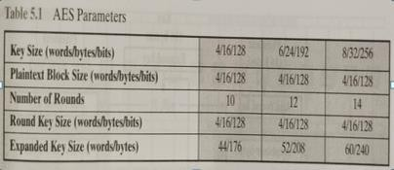
- AES (13)

AES Parameters:

AES Structure:
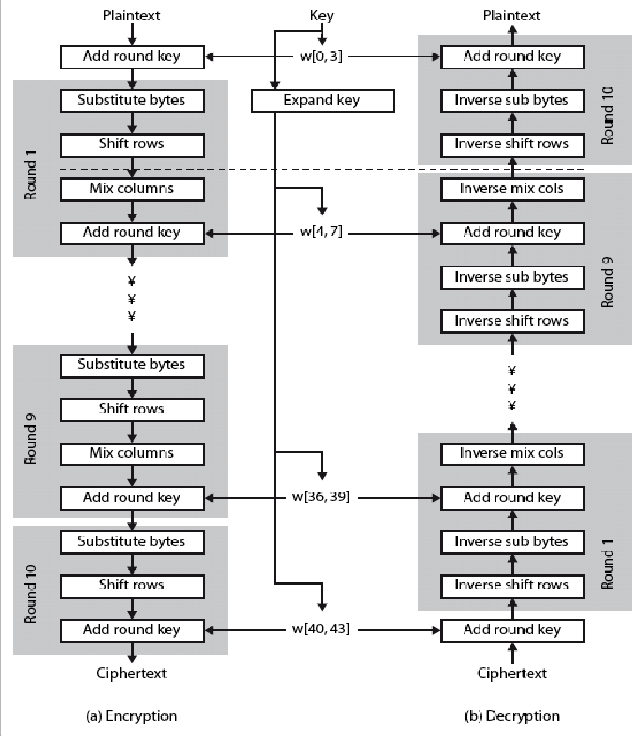

- Data block of 4 by 4 matrix of bytes is state
- Key is expanded to array of words
- First N-1 rounds have 4 state transformations
- byte substitution (1 S-box used on every byte)
- shift rows (permute bytes between groups/columns)
- mix columns (subs using matrix multiply of groups)
- add round key (XOR state with key material)
- Last round has 3 state transformation
- does not have mix column operation
- In addition, there is an initial “round”,
- Which only performs “add round key” operation
Block cipher mode of operation (13)

Electronic Code Book (ECB)

Cipher Block Chaining (CBC)

Cipher Feedback Mode (CFB)

Output Feedback Mode (OFB)

Counter Mode (CTR)

- Electronic Code Book (ECB)

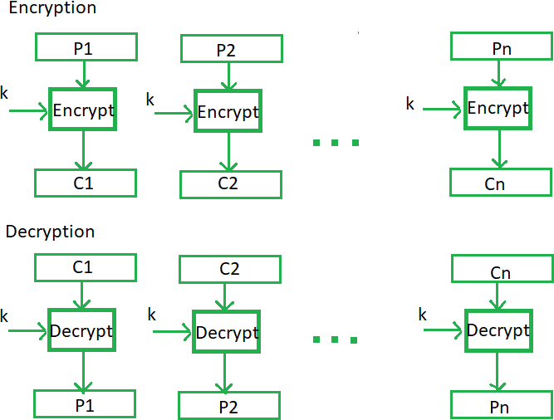

It is easier because of direct encryption of each block of input plaintext and output is in form of blocks of encrypted ciphertext.
Generally, if a message is larger than b bits in size, it can be broken down into a bunch of blocks and the procedure is repeated.
Advantages of using ECB
Parallel encryption of blocks of bits is possible,
Faster way of encryption.
Disadvantages of using ECB
Not secure as there is a direct relationship between plaintext and ciphertext.

Cipher Block Chaining (CBC)
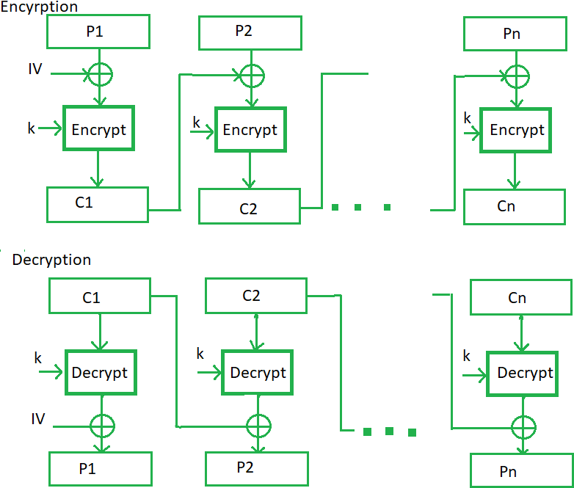

In CBC, the previous cipher block is given as input to the next encryption algorithm after XOR with the original plaintext block.
Advantages of CBC
CBC works well for input greater than b bits.
CBC is a good authentication mechanism.
Better resistive nature towards cryptanalysis than ECB.
Disadvantages of CBC
Parallel encryption is not possible since every encryption requires a previous cipher.

Cipher Feedback Mode (CFB)
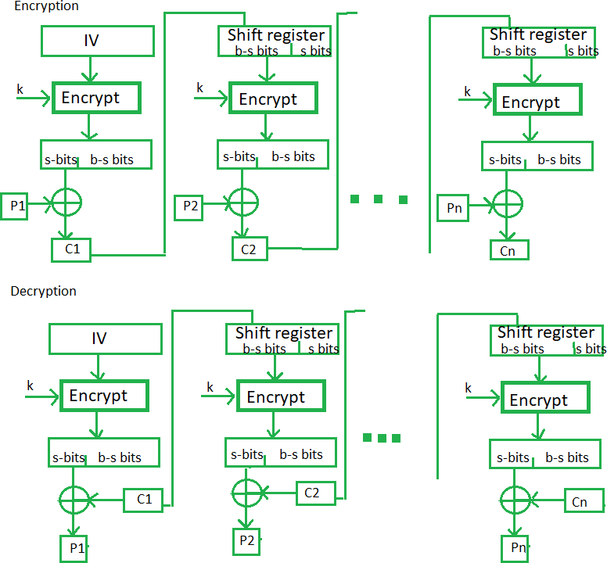

In this mode the cipher is given as feedback to the next block of encryption with some new specifications: first, an initial vector IV is used for first encryption and output bits are divided as a set of s and b-s bits. The left-hand side s bits are selected along with plaintext bits to which an XOR operation is applied. The result is given as input to a shift register having b-s bits to lhs,s bits to rhs and the process continues. both of them use encryption algorithms.
Advantages of CFB
In CFB, some data loss due to the use of shift register, thus it is difficult for applying cryptanalysis.

Output Feedback Mode

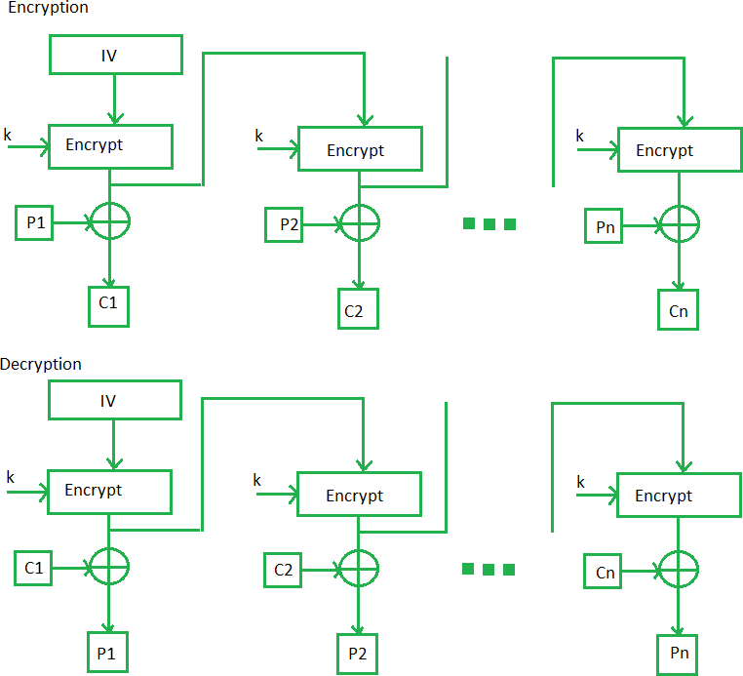

The output feedback mode follows nearly the same process as the Cipher Feedback mode except that it sends the encrypted output as feedback instead of the actual cipher which is XOR output.
In this output feedback mode, all bits of the block are sent instead of sending selected s bits.
The Output Feedback mode of block cipher holds great resistance towards bit transmission errors.
It also decreases the dependency or relationship of the cipher on the plaintext.
Advantages of OFB
In the case of CFB, a single bit error in a block is propagated to all subsequent blocks. This problem is solved by OFB as it is free from bit errors in the plaintext block.

Counter Mode

- Every time a counter-initiated value is encrypted and given as input to XOR with plaintext which results in ciphertext block.
- The CTR mode is independent of feedback use and thus can be implemented in parallel.

Advantages of Counter

- In Counter, different counter value for each block, the direct plaintext and ciphertext relationship is avoided. This means that the same plain text can map to different ciphertext.
- Parallel execution of encryption is possible.
